RENTAL CONNECT
A verified rental marketplace connecting landlords and tenants directly
System Design Document
System Architecture · Entity Relationship Diagram · System Logic
Prepared for project kickoff and development planning

Table of contents
Table of contents 2
1. Project overview 3
2. System architecture 3
2.1 Client layer 3
2.2 Application layer 4
2.3 Data and storage layer 4
2.4 External services 4
3. Entity relationship diagram 5
3.1 Key relationships 5
3.2 Design notes 6
4. System logic 7
4.1 Authentication and onboarding 7
4.2 Posting a rental listing 8
4.3 Search and filter 9
4.4 Messaging between tenant and landlord 10
5. Supporting non-functional requirements 12
Data validation 12
Data security 12
Cross-platform delivery 12
System stability 12
Trust and moderation 12

1. Project overview
Rental Connect is a cross-platform mobile application that connects landlords directly with tenants searching for rental housing. The system removes the broker as an intermediary, addressing two core problems in the rental market: tenants being scammed by unverified listings, and tenants being charged inflated prices by brokers acting as gatekeepers to information landlords would otherwise share for free.
The application serves two primary user groups, landlords and tenants, each with a dedicated dashboard, plus an administrative layer for moderation and trust management. The sections below describe the system architecture, the data model (entity relationship diagram), and the operational logic governing the core workflows.
Core design principle
Every architectural and logic decision in this document is made in service of one goal: trust. A tenant should be able to look at a listing and have good reason to believe it is real, accurately priced, and posted by the person who actually owns or manages the property.

2. System architecture
The system follows a layered client-server architecture. The mobile application (built cross-platform) communicates with a backend API over HTTPS. The backend is organized into logical services that share a single relational database, rather than separate microservices — this keeps the system simple to build and maintain at MVP stage, while still being cleanly separable later if traffic demands it.
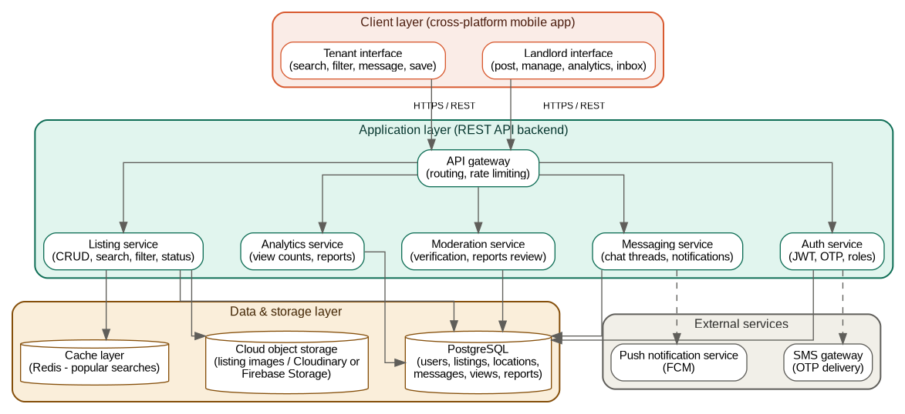
Figure 1. System architecture — client, application, data, and external service layers

2.1 Client layer
A single cross-platform codebase (e.g. Flutter) renders two distinct interface modes depending on the logged-in user's role: a tenant interface optimized for browsing, searching, and filtering listings, and a landlord interface optimized for posting and managing listings and tracking engagement. Using one codebase for both roles, gated by role-based routing after login, avoids maintaining separate apps for Android and iOS.

2.2 Application layer
All client requests pass through an API gateway, which handles routing and rate limiting before forwarding requests to the relevant service:
- Auth service — registration, login, OTP verification, JWT issuance, and role assignment.
- Listing service — create, read, update, delete operations on rental listings, plus search and filter logic.
- Messaging service — conversation threads between tenants and landlords, tied to specific listings.
- Analytics service — records and aggregates listing views for landlord-facing statistics.
- Moderation service — landlord verification review and tenant-submitted reports on suspicious listings.

2.3 Data and storage layer
PostgreSQL is the system of record for all structured data — users, listings, locations, messages, views, and reports. A relational database is appropriate here because the data is highly interconnected (a listing belongs to a landlord, has one location, many images, many views) and benefits from enforced referential integrity. Listing images are stored in cloud object storage rather than the database, with only the resulting URLs stored in PostgreSQL. An optional Redis cache layer stores results for frequently repeated searches (e.g. "Wakiso, under 300,000") to keep the browse experience fast as listing volume grows.

2.4 External services
Two external integrations support the core experience: an SMS gateway for delivering OTP codes during phone verification, and a push notification service (such as Firebase Cloud Messaging) for alerting users to new messages in real time.

3. Entity relationship diagram
The data model centers on two entities: users and listings. Every other table exists to support one of the core workflows — locations support search and filtering, listing_images supports the visual browsing experience, listing_views supports landlord analytics, messages supports tenant-landlord communication, and reports supports content moderation.
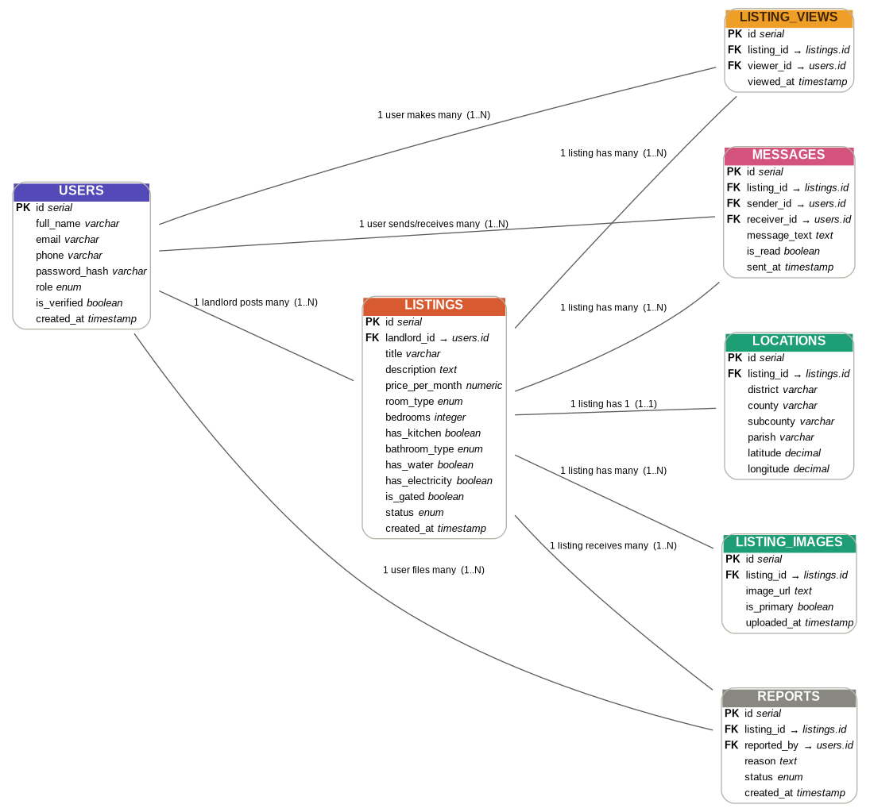
Figure 2. Entity relationship diagram for Rental Connect

3.1 Key relationships
- A landlord (in users) can post many listings — one-to-many.
- Each listing has exactly one location record — one-to-one, kept separate from listings to keep filter queries clean and to allow future map/geo features without restructuring.
- Each listing can have many images — one-to-many, supporting a photo carousel in the UI.
- Each listing accumulates many view records over time, and each user can generate many views — this many-to-many relationship, captured through the listing_views table, is what powers the "views per listing" statistic on the landlord dashboard.
- Messages are linked to both a listing and the two participating users (sender and receiver), so a conversation is always scoped to a specific rental rather than being a generic, contextless chat.
- Reports link a listing to the user who flagged it, feeding the moderation workflow.

3.2 Design notes
Constraints are enforced at the database level wherever possible, not only in application code — for example, role is restricted to tenant, landlord, or admin, and price_per_month must be greater than zero. This means that even if a bug exists in the backend validation logic, the database itself will not accept structurally invalid data. Indexes are applied to the columns used most often in tenant search and filter operations — district, county, price_per_month, and status — since these are the columns a full-text or range query will hit on nearly every browse request.

4. System logic
This section walks through the operational logic of the four workflows that define the product: account creation and verification, posting a listing, searching and filtering listings, and messaging between a tenant and a landlord. Each flow is shown as a diagram followed by a written walkthrough of the decision points and what happens at each one.

4.1 Authentication and onboarding
Verification at signup is the system's first line of defense against fake landlord accounts, so OTP confirmation is mandatory before a user record is treated as active, not an optional step that can be skipped.
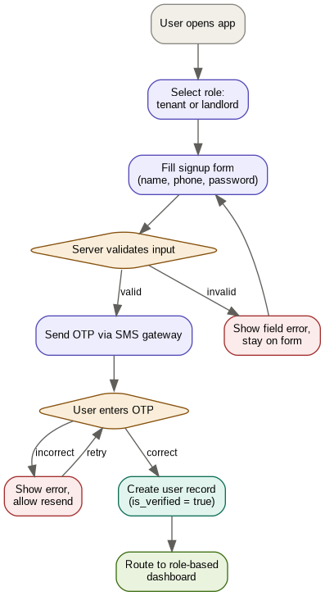
Figure 3. Authentication and onboarding flow
Walkthrough:
- The user selects a role — tenant or landlord — before filling in any details, since this determines which dashboard and permissions they receive afterward.
- Signup details are validated on the server regardless of what client-side checks already passed, since client-side validation can always be bypassed by a modified request.
- On successful validation, an OTP is generated and sent through the SMS gateway to the phone number provided.
- The account is only marked is_verified = true after the correct OTP is entered. Until then, the account exists but cannot post listings (if a landlord) or message anyone (if a tenant).
- Once verified, the user is routed to the dashboard matching their role.

4.2 Posting a rental listing
This flow has two independent validation checkpoints — once on the client for immediate feedback, and again on the server, since the server can never trust that the client's checks actually ran.
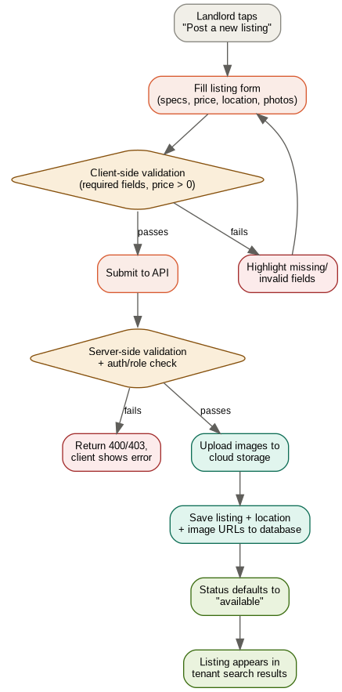
Figure 4. Listing posting flow
Walkthrough:
- The landlord fills in the listing form: title, description, price, room type, bedroom count, amenities (kitchen, bathroom type, water, electricity, gated status), location, and at least one photo.
- Client-side validation catches obvious problems immediately — empty required fields, a price of zero or below — without a round trip to the server.
- On submission, the server independently re-validates all fields and additionally confirms that the requesting user is authenticated and holds the landlord role for this specific listing (relevant on edit/delete, to prevent one landlord from modifying another's listing).
- Images are uploaded to cloud object storage first; only the resulting URLs are written to the database, keeping the relational database lightweight.
- The listing record, its location record, and its image records are saved together. The listing's status defaults to available.
- The listing immediately becomes visible to tenants browsing or searching that area.

4.3 Search and filter
This is the highest-traffic read path in the system, so the logic is built around two performance techniques: indexed database columns and a cache layer for repeated queries, rather than scanning the full listings table on every request.
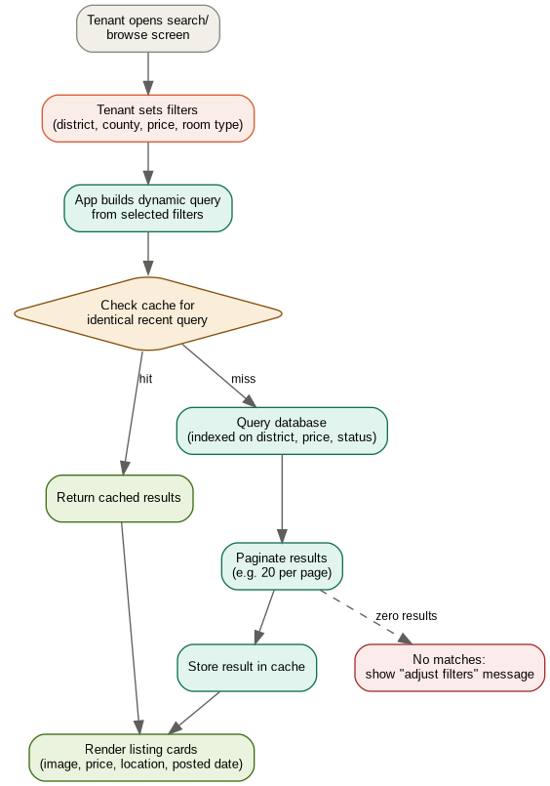
Figure 5. Search and filter flow
Walkthrough:
- The tenant sets one or more filters — administrative location (district, county, subcounty), price range, room type, and amenities.
- The app constructs a single dynamic query that combines whichever filters are active, rather than maintaining separate hardcoded queries for every possible filter combination.
- The system checks whether an identical query was run recently and is still cached. If so, results are returned immediately without touching the database.
- On a cache miss, the query runs against PostgreSQL using the indexes on district, price_per_month, and status, then results are paginated (for example, twenty listings per page) rather than returned all at once.
- Fresh results are written to the cache before being returned, so the next tenant running the same search benefits from the cached version.
- If no listings match, the interface shows a clear empty state suggesting the tenant adjust their filters, rather than a blank screen.

4.4 Messaging between tenant and landlord
Every conversation is scoped to a specific listing rather than being a free-floating chat, which keeps context attached. A landlord with many listings can tell at a glance which property a given message is about.
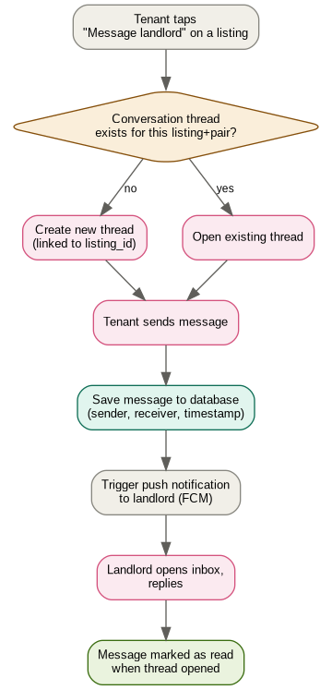
Figure 6. Messaging flow
Walkthrough:
- The tenant taps "Message landlord" from a listing's detail page.
- The system checks whether a conversation thread already exists between this tenant and landlord for this specific listing. If not, a new thread is created and linked to the listing_id; if one exists, it is simply reopened.
- The tenant's message is saved to the database with sender, receiver, and timestamp.
- A push notification is sent to the landlord through the notification service, so they are alerted without needing to keep the app open.
- When the landlord opens the thread and replies, the original message is marked as read.

5. Supporting non-functional requirements
The functional flows above depend on a set of system-wide qualities that are not tied to any single feature, but are required across all of them.

Data validation
Applied in two layers consistently: client-side for immediate user feedback, and server-side as the actual enforcement point, since server-side validation cannot be bypassed by a modified or scripted request. Database-level constraints (such as CHECK constraints on enumerated fields) serve as a final backstop.

Data security
- Passwords are hashed (never stored in plain text) before being written to the database.
- Authenticated requests use JWTs, validated on every protected endpoint.
- Authorization checks confirm not just that a user is logged in, but that they own the specific resource they are trying to modify (for example, a landlord can only edit their own listings).
- Phone number verification through OTP reduces the likelihood of fake or disposable landlord accounts.

Cross-platform delivery
A single codebase target (such as Flutter) renders natively on both Android and iOS, avoiding the cost and inconsistency of maintaining two separate native applications for the same feature set.

System stability
- Centralized error handling on the backend prevents an unhandled exception in one request from affecting other requests.
- Database connection pooling avoids exhausting available connections under concurrent load.
- Load testing before launch establishes how the system behaves under realistic concurrent usage, rather than discovering this after users are affected.
- Crash reporting and monitoring tools surface issues proactively, rather than relying on user complaints as the first signal that something is broken.

Trust and moderation
Since the product's stated purpose is to reduce rental scams, the report and moderation flow is treated as a required part of the MVP rather than a future addition. Every listing exposes a visible "report" action, and reports are queued for admin review rather than auto-removing or auto-ignoring flagged content.

